Lab - Provisioning an Azure SQL Database and Connecting via Azure Data Studio
This hands-on lab will guide you through creating a fully managed Azure SQL Database using the Azure Portal and then connecting to it with Azure Data Studio.
By the end, you will have an Azure SQL Database set up with a new SQL server (using a username/password for authentication) and will be able to connect and query it from Azure Data Studio.

Learning Objectives
- SQL Database Provisioning: Create an Azure SQL Database and a new SQL Server (logical server) with SQL authentication credentials.
- Security Configuration: Understand Azure SQL Database firewall options – including allowing Azure services and adding client IP addresses – and configure them to enable connectivity.
- Azure Data Studio Connection: Connect to the Azure SQL Database using Azure Data Studio with the SQL login, and run a simple query to verify the connection.
- Troubleshooting: Recognize common issues (such as firewall access problems or network port blocks) and know how to resolve them.

Steps to Follow
- Login to Azure Portal with valid credentials
- Create a resource group say devops-sql-lab-<your_name>
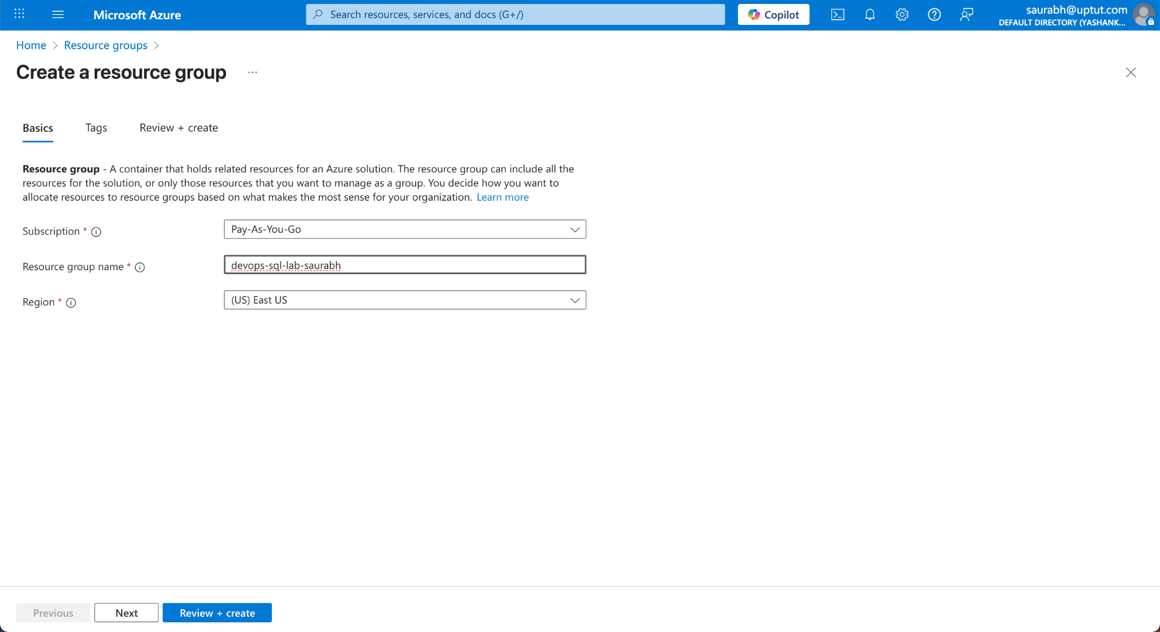

Create a SQL Database
- Create a new resource SQL Database
- Configure Basic Settings: On the Basics tab of the Create SQL Database form, enter the following details:
- Subscription: Select the Azure subscription you want to use.
- Resource Group: Select the resource group created above
- Database Name: Enter a unique name for your database (e.g., devops-sqldb-saurabh). This is the name of the database itself, not the server.
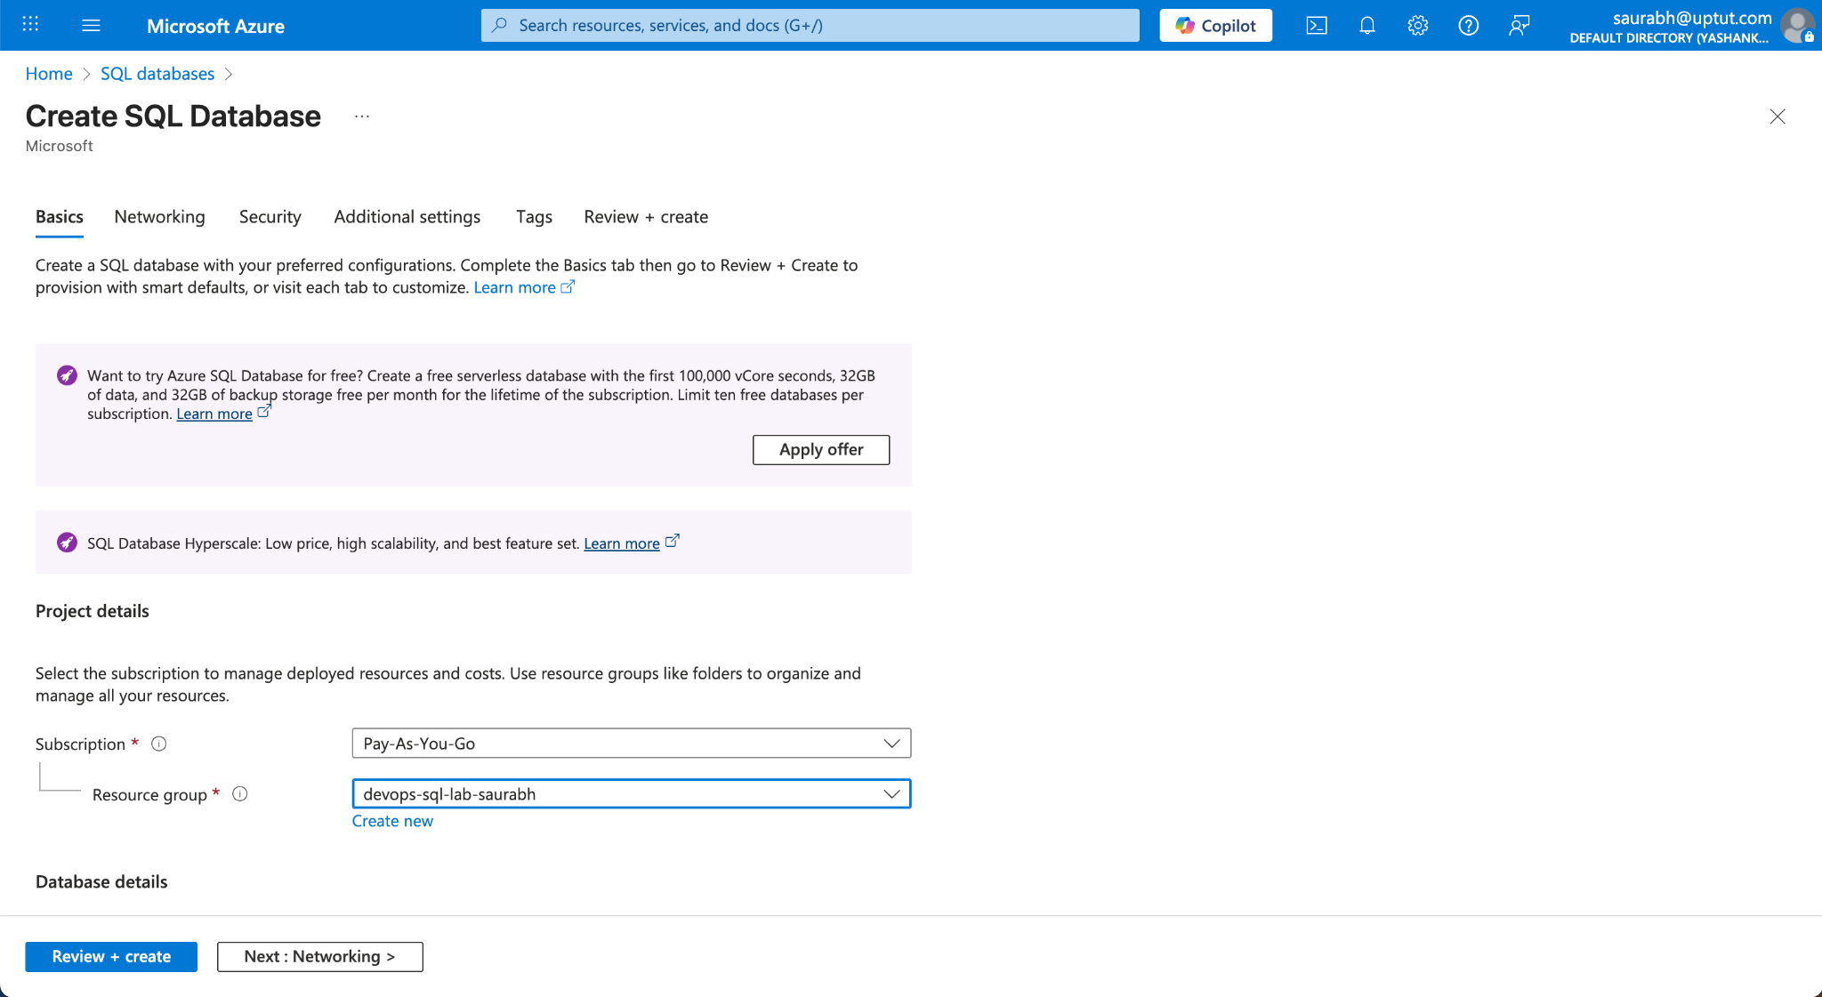
Server: Click Create new to set up a new SQL Server (logical server) for the database. In the New Server form, fill in:
- Server name: Choose a globally unique server name (e.g., devops-sql-server-<your_name>). The name must be all lowercase and unique across all of Azure. The portal will alert you if the name is already taken.
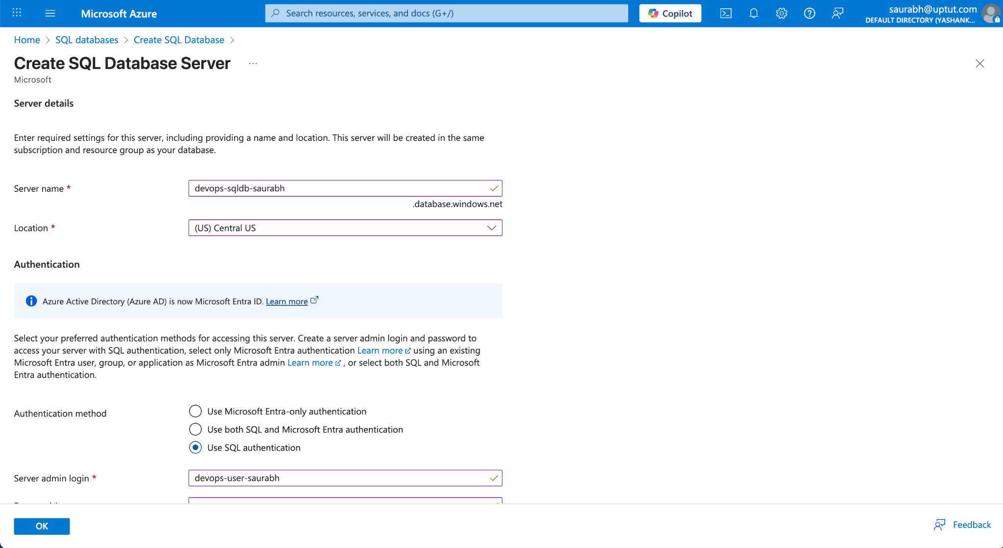
- Location: Pick a region close to you or your users (e.g., "Central US").
- Authentication method: Select Use SQL authentication (this allows a username/password login for the server).
Server admin login: Enter a username for the server admin (for example, azureuser). This will be the SQL Login user for your server.
- Password: Enter a strong password and confirm it. Make sure to remember these credentials – you will use them to connect to the database.
- Click OK to create the server.
- Want to use SQL elastic pool: Leave this as No (elastic pools are not needed for this simple lab).
- Compute + storage: You can stick with the default configuration (which might be a General Purpose serverless tier for development).
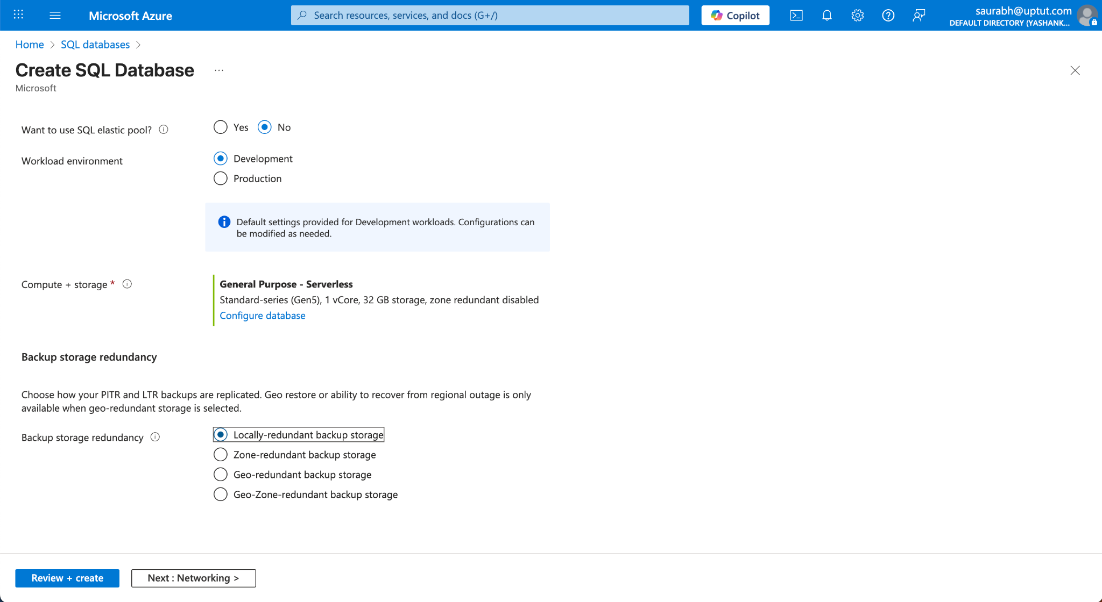
- Networking - Configure Firewall Settings: Still in the SQL Database creation wizard, switch to the Networking tab. Here we will ensure your database can be accessed:
- Connectivity method: Select Public endpoint (allows connections over the internet).
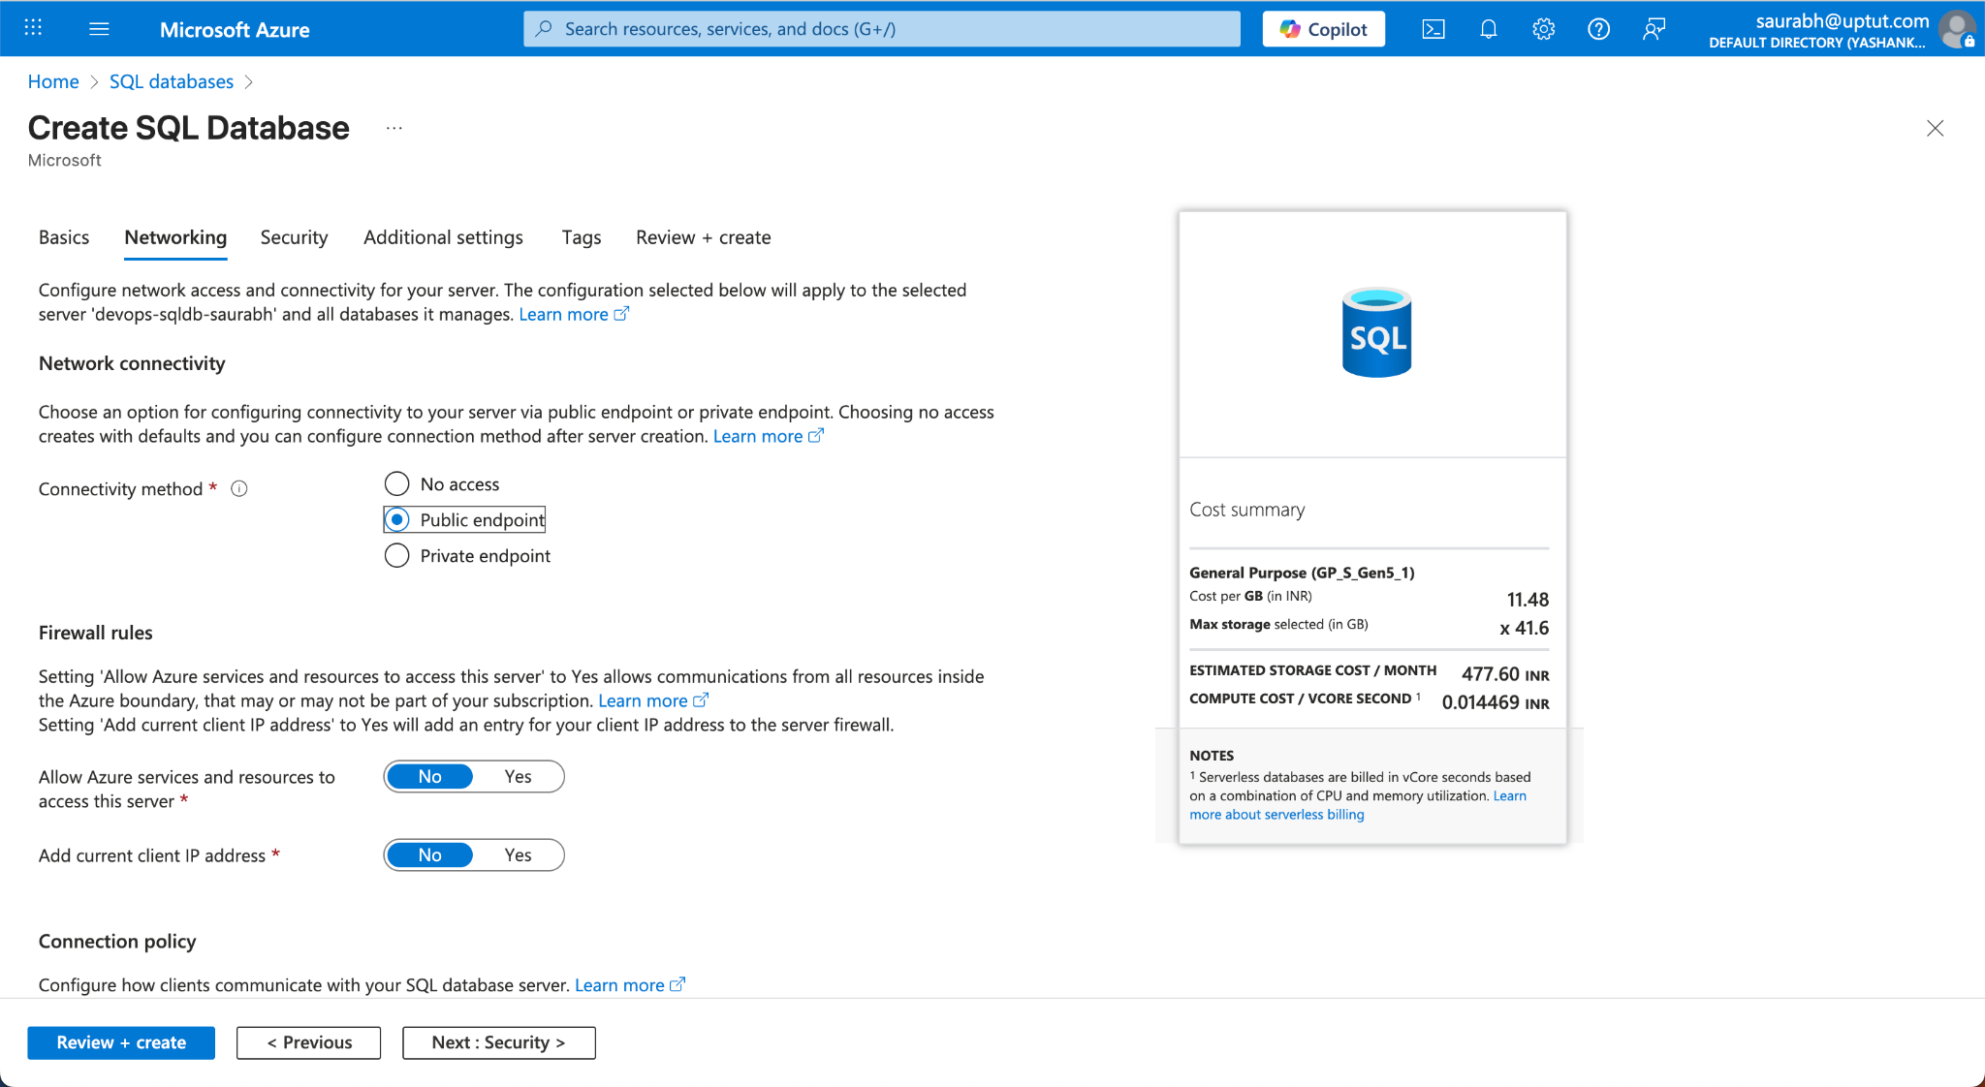
Additional Settings (Optional Data): Switch to the Additional settings tab. For a first-time exploration, you can choose to create the database with some sample data:
- Use existing data: Select Sample to load the AdventureWorksLT sample database. This will create tables and data that you can query right away, which is helpful for learning. (If you prefer an empty database, leave this as None.)
- Leave other fields (like collation or backups) at their defaults for now.
Review and Create: Click Review + create. The portal will validate the settings. Review the summary of your configuration. If everything looks good, click Create to provision the Azure SQL Database.
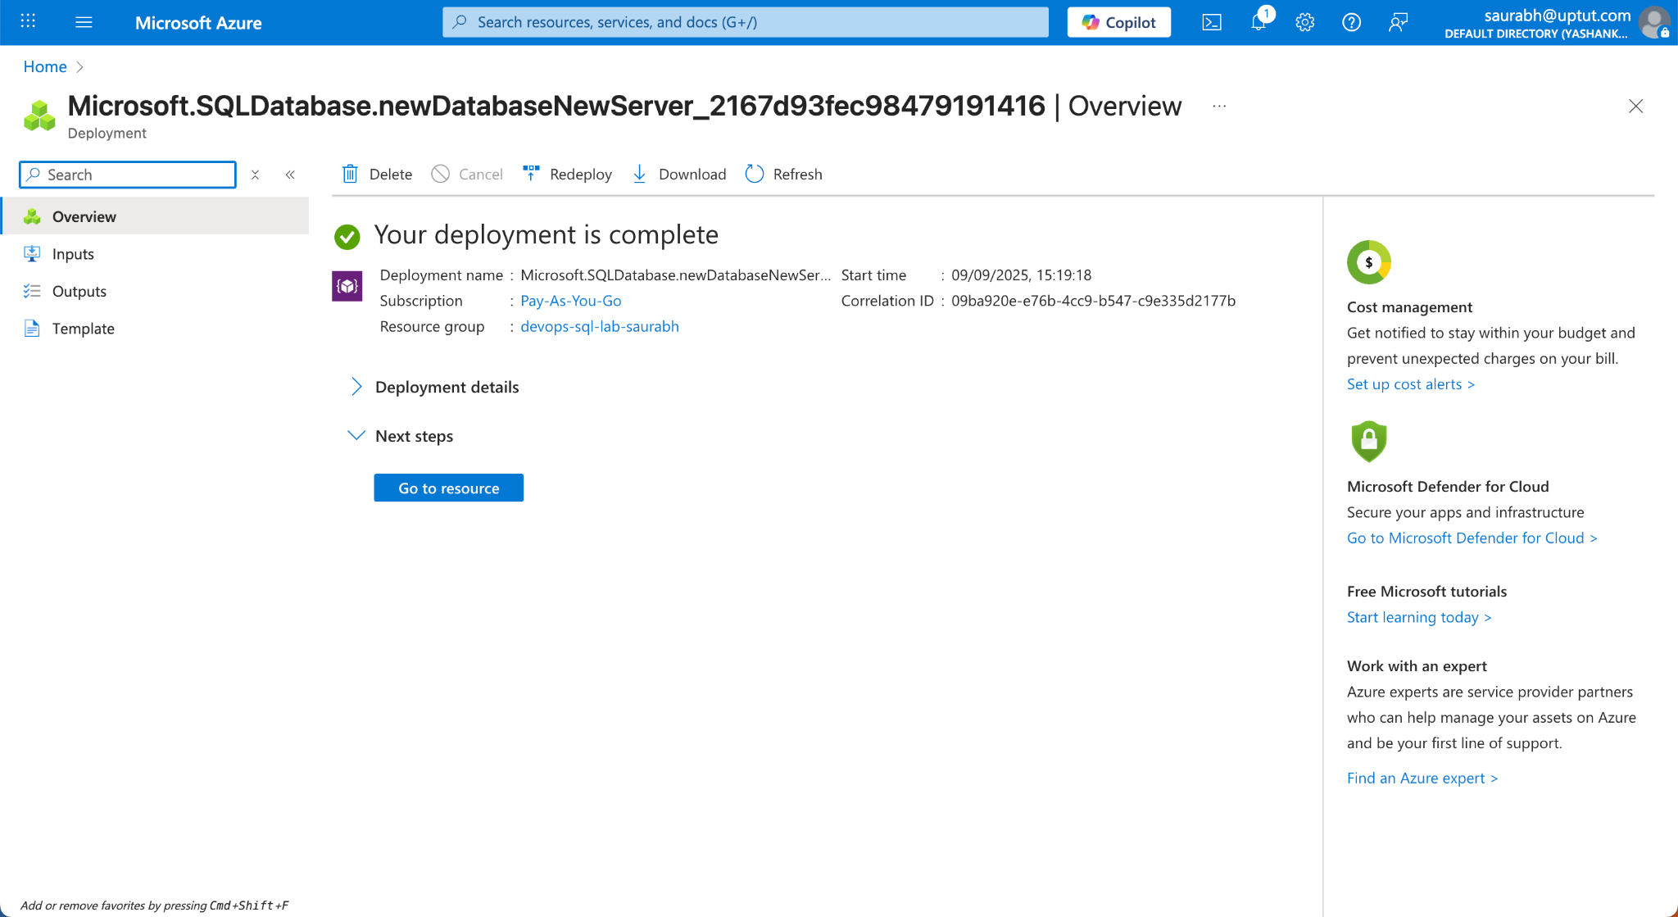

Add a firewall Rule:
In this lab, we will add a simple rule to allow access from everywhere.
Note - Do not use this production or real world. There are better ways of providing access

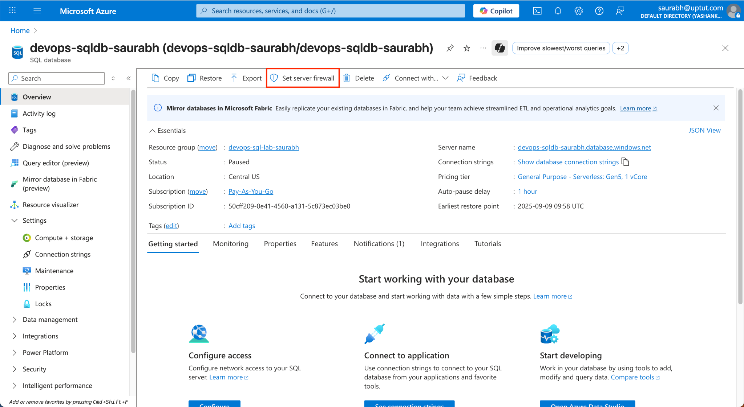

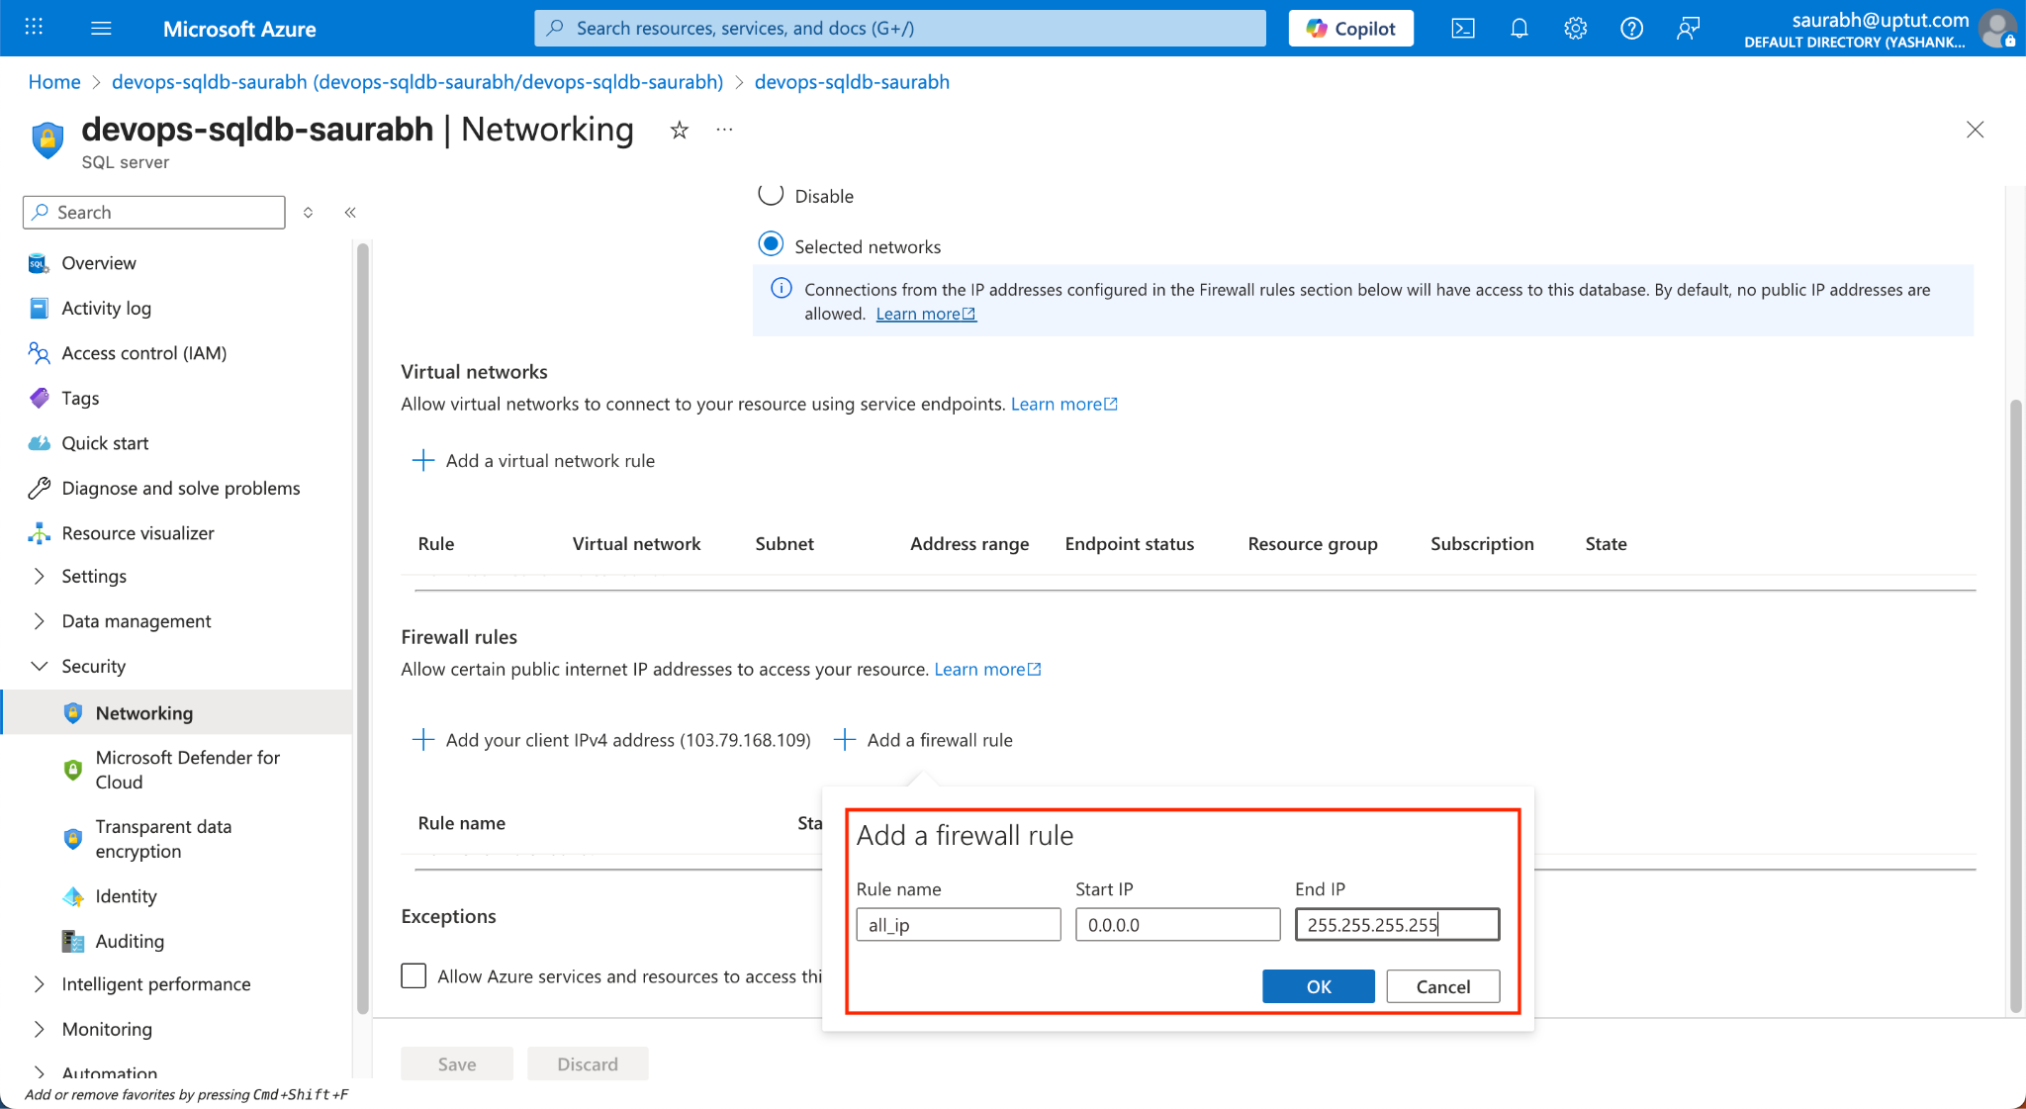

Connect using Azure Data Studio:
Now that the Azure SQL Database is up and firewall configured, we’ll connect to it from Azure Data Studio (ADS).
Install Azure Data Studio: If you don't have it installed, download and install Azure Data Studio for your OS. Launch Azure Data Studio once installed.
Open Connection Dialog: On the Welcome page or the left sidebar, click New Connection (the plug icon). A connection form will appear for the new connection details.
Azure Data Studio New Connection dialog, where you'll enter the server and login details.
Fill in Connection Details: In the connection form, enter the following:
Server: Fully qualified server name – this is the server name you noted earlier (e.g. myfirstsqlserver123.database.windows.net). Make sure to include the “.database.windows.net” part, as the server name must be the full address.
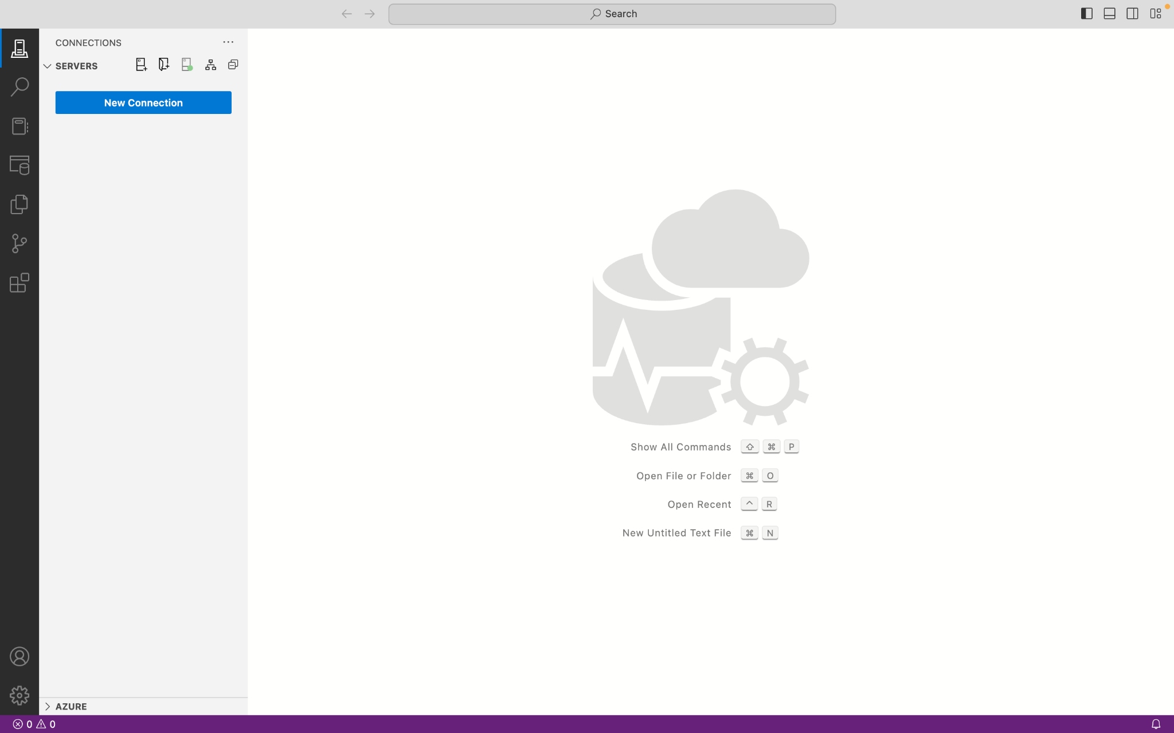
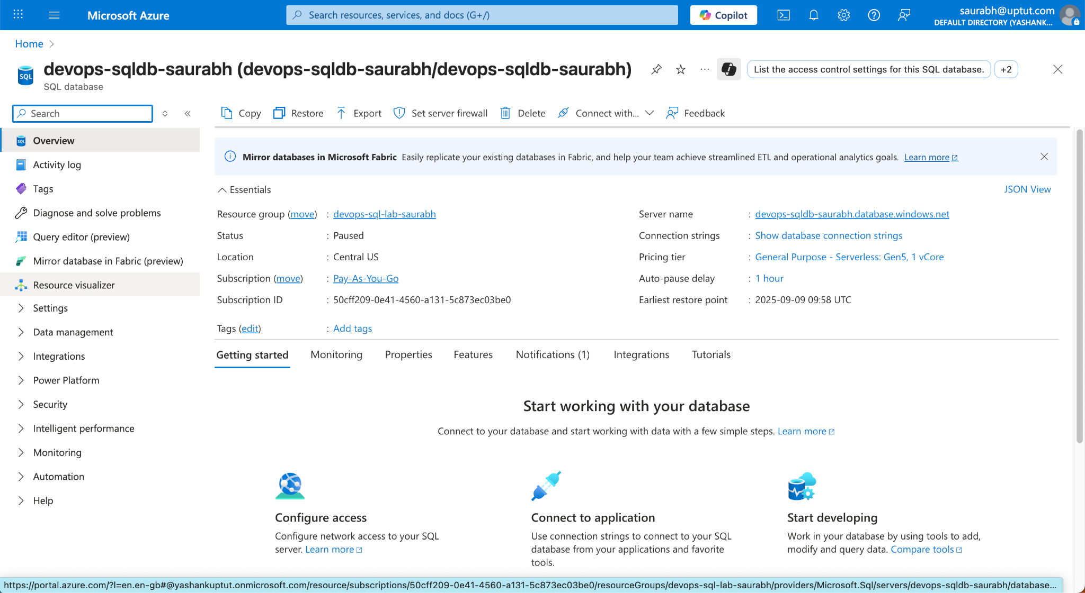
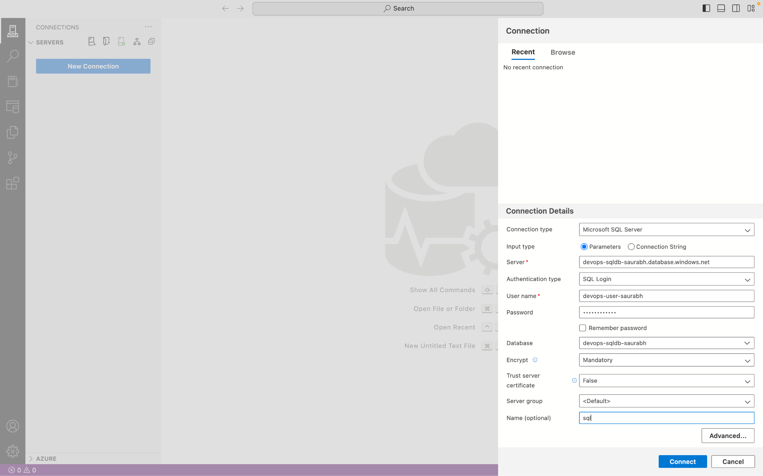
Authentication: Choose SQL Login (since we created a SQL username/password).
User name: The server admin login you specified (e.g. azureuser).
Password: The password you created for that admin login. You can check "Save Password" if you want ADS to remember it.
Database name: (optional) You can leave this blank to connect to the server’s default database (which will be the master database). If you want to connect directly into your new database, you can select it from the dropdown after the first connection, or type its name here (e.g. MyFirstDatabase).
Leave Server Group as <Default> (or use any grouping if you have multiple connections).
Click Connect. Azure Data Studio will attempt to connect to your Azure SQL Database server using the provided info. If the credentials are correct and the firewall is properly set, you will be connected. You should see your server and database appear in the Servers panel in ADS.
Troubleshooting & Common Issues:
If you encounter any issues during the above steps, consider the following fixes:
- Incorrect Credentials: Ensure you’re using the exact server admin username and password you set. Remember that the server name portion is part of the connection address, not the username. The username is just the one you created (e.g. "azureuser"), not an email.
- Server Name Issues: Make sure you include the full server name (including “.database.windows.net”). If you omit this, the connection will fail because Azure SQL Database’s server is only reachable via its fully qualified name.
- Port 1433 Blocked: Azure SQL Database communicates over port 1433. If you are on a corporate or secure network, outbound traffic on port 1433 might be blocked by your organization’s firewall. In that case, you might need to use a different network or request IT to open port 1433 for your machine.
- Deployment Not Finished: If you try to connect before the database deployment is complete, the connection will fail. Ensure the Azure deployment succeeded (you should see a “Your deployment is complete” message in the portal) before connecting.

